**Instructions for Preparing Papers for IJARI [Title style: Times New Roman 16, bold, Left]**

Author 1,*, Author 2, Author 3 [Author style: Times New Roman 12, Left]

*1 Affiliation, address [Author style: Times New Roman 11, Left]

2 Affiliation, address [Author style: Times New Roman 11, Left]

3 Affiliation, address

**Article Info**

Article history:

Received XX X

Received in revised form XXX

Accepted XXX

Available online XXX

**Keywords**

Keyword 1, Keyword 2, Keyword 3, Keyword 4, Keyword 5. [Keywords style: Times New Roman 9, justified]

**ABSTRACT**

Detailed instructions for preparing your paper submitted to IJARI are given as follows. Please be responsible for the quality and appearance of your work.

It’s strongly recommended that you directly type over the template or just cut and paste from another document and use markup styles. Please keep in mind all the way through the preparation, do not modify page setup in this template, such as fonts, font sizes, line spacing, margin, uppercase and lowercase, the order of sections, etc.

The abstract section is mandatory, with a word limit of 200 words. The scope, aims, results and conclusions may be summarized here. Avoid inserting any reference in this section.

In the Keywords section, please capitalize the initial letter of each keyword. Enter the words or phrases in alphabetical order, separated by commas. There is a maximum of 5 keywords. [Abstract style: Times New Roman 9, justified]

# Introduction

Throughout the main body of your paper, please follow these prescribed settings: 1) the font is nothing but Times New Roman; 2) in terms of font size, almost all the words are typed in 10 points except: a. the words in tables are in 9 pts; b. notes under tables or figures are in 8 pts; 3) the basic line spacing is single spacing; 4) in most cases, 12 pts spacing shall be left above and below any heading, title, caption, formula equation, figure and table, except that, 24 pts spacing shall be left above Level 1 headings (such as the title “Introduction” of this section). About the levels of headings, please see “3. Section Headings”.

Actually, as mentioned in the abstract section, it will be rather easy to follow these rules as long as you just replace the “content” here without modifying the “form”.

2. Page Setup

The book size will be in A4 (210 x 297 mm). Just as it is now, it uses custom margins: left margin 12.95 mm, right margin 12.95 mm, top margin 13.97 mm and bottom margin 20.06 mm. As the body text is divided into two columns in equal width (87.37 mm), the spacing between them is 8.89 mm. Please make sure that you do not exceed the indicated type area.

The first line of each paragraph shall be indented by one character, approximately the length occupied by two lower-case letters here.

The number of pages for the manuscript can vary, including all the sections. Please make sure that the whole text ends on an even page. **Please DO NOT insert page numbers.** Headers or the Footers are reserved for the technical editing of the volume by the IJARI editors for page nos.

**Corresponding Author,**

**E-mail address:** [bhupendradce2008@gmail.com](mailto:bhupendradce2008@gmail.com); Phone No--+91-

**All rights reserved:** <http://www.ijari.org>

3. Section Headings

The way that section titles and other headings are displayed in these instructions, is meant to be followed in your paper.

Level 1: Times New Roman, 10, bold, all letters capitalized, 24 pts spacing above heading, 12 pts below heading, Example: “**3. Section Headings**”

Level 2: Times New Roman, 10, bold, only the first letter as well as proper nouns capitalized, 12 pts spacing above heading, 12 pts spacing below heading. However, when a Level 2 heading is directly above a Level 1 spacing, just leave 12 pts spacing between them instead of 24 pts. Example: “**4.1 Paper title**”.

Level 3: Times New Roman, 10, not bold, only the first letter as well as proper nouns capitalized, 12 pts spacing above heading, no spacing below heading. However, when a Level 3 heading is directly above a Level 2 spacing, just leave 12 pts spacing between them instead of 24 pts. Example: “4.2.1 Name”

No more levels successive to Level 3 are allowed. If you have to add some “Level 4” heading, just place it at the beginning of a paragraph, underline it, and follow it with a full stop and immediately the text. For example:

The heater tube. This device is used as the electrical resistance for providing heat input. D.C. voltage is applied at the……

DO NOT begin a new section directly at the bottom of the page, instead, move the heading to the top of the next page.

# 4. More Details about Paper Title And Author Information

**4.1 Paper title**

Paper titles should be written in upper-case and lower-case letters, not all upper-case, e.g., “Instructions for Preparing Papers for **IJARI***”*. Do not use capital letters for prepositions, articles or conjunctions unless one is the first word.

Avoid writing long formulas with subscripts in the title; short formulas that identify the elements are fine (e.g., “Nd–Fe–B”).

**4.2 Author information**

4.2.1 Name

Full names of authors are preferred in the author field, but are not required.

4.2.2 Affiliation

Different affiliations shall be listed in separate lines. Do not insert any punctuation at the end of each affiliation. If all the authors are affiliated to the same organization, type that affiliation just once.

4.2.3 Superscripts

To match authors and their own affiliations, please insert numerical superscripts, i.e., “1, 2, 3, 4 …” followed by a space, after name and, correspondingly, before affiliation. If all the authors are affiliated to the same one organization, any number is no need.

Do not forget to denote the corresponding author with a superscript asterisk (*). Offer only one valid email of the corresponding author.

# 5. Math

# 5.1 Equations

1. Tool: Please use either the Microsoft Equation Editor or the *MathType* add-on (http://www.mathtype.com) for equations in your paper (Insert | Object | Create New | Microsoft Equation *or* MathType Equation). “Float over text” should *not* be selected.
2. Format: The size of equation is 10 pts. Remember to leave 12 pts both above and below an equation. Set the equation flush left, without indenting it.
3. Numbering: Make sure that placing and numbering of equations is consistent throughout your manuscript. References to the equations should be as Eq(1). Make the number of an equation flush-right. For example:

 (1)

**5.2 Measurement units and numbers**

Please use the SI set of units as much as possible. Wherever the application domain uses a different set of units widely, please minimize the use of non-standard units or non-standard symbols for those units. As examples, the use of “a” for year (annum) is depreciated and the use of “y” is encouraged instead. Similarly, “h” should be used for hours instead of “hr” and “t” instead of “ton” or “tonne”. It is important to take care of the case in which the measurement units are typed. E.g. “Km” does not mean “kilometres”, but “Kelvin-meters”.

When providing numerical values followed by measurement units, please leave a regular space or non-breaking space between each value and the measurement unit. This also includes percentages and degrees Celsius (e.g. 42 % or 35 %, 234 °C, 504 K). This rule also applies to the unit for litre, which is recommended to be capital “L”.

The authors are encouraged to render the numbers specifying the dot as a decimal separator and the comma as a thousands separator. Please use the British style for numbers – i.e. 1,000,000 and not 1000000 or 1 000 000.

# 6. Tables and Figures

**6.1 General**

Briefly and descriptively title each table and caption each figure. Place figure captions below the figures whereas table titles above the tables. Please do not include captions as part of the figures, or put them in “text boxes” linked to the figures. Also, do not place borders around the outside of your figures.

1. All the table titles and figure captions should be centered, Times New Roman font and 10 pts in size. Just capitalize the first letter of words, phrases and sentences which are included in tables and figures.
2. Reference each table and figure within the text by writing: e.g., Table 1 or Figure 1 (instead of Tab. 1 or Fig. 1). If possible, place tables and figures in the order mentioned in the text, at top or bottom of page, as close as possible to text reference.
3. Allow 12 pts spacing between the table title and the table (or between the figure and its caption). The equal spacing is allowed between the table or figure and the following text.

## 6.2 Tables

Words within a table should use 9pts, left aligned. The table number should be in bold type.

In general, if a table is too long to fit one page, the table number and heading should be repeated on the next page before the table is continued. Alternatively the table may be spread over two consecutive pages (first an even numbered, then an odd-numbered page) turned by 90, without repeating the heading. Please do not use bold font in tables.

Here is a table template:

**Table 1.** Table title

|  |  |  |
| --- | --- | --- |
| Heading1 | Heading 2 | Heading 3 |
|  |  |  |

Notes: 1. If you have to attach a note for further explaining some data in the table, please use 8 pts font size here. 2. If more than one note are to be attached, please number them with “1, 2, 3 …” and separate them with a period or a semicolon. 3. The right and left borders of the note area must be aligned in relation to those borders of the table above it no matter what the table size is. 4. Please distribute your notes evenly between the margins.

## 6.3 Figures

Please make sure that the captions are on the same page with the relevant figures and tables. Please keep captions short – taking preferably 1 line. If a caption is a complete sentence, place a period at the end of it. If not, then place no punctuation at the end.

Figures and captions must be centered. Any word, number, shape and symbol on figures must be discernible when the page zoom level stands at 120%.

Various figures can be accepted. Several examples cited from papers published in previous IJARI journal issues are as follows. Please pay special attention to how much line spacing are allowed in different cases:

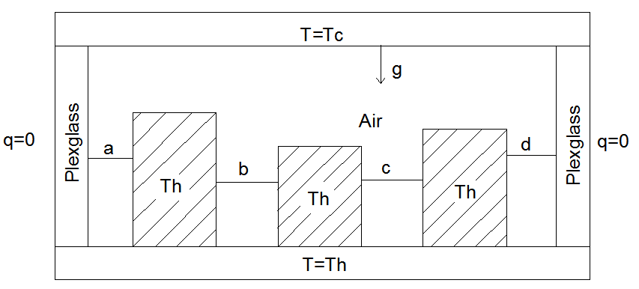

**Fig. 1** Cavity geometry

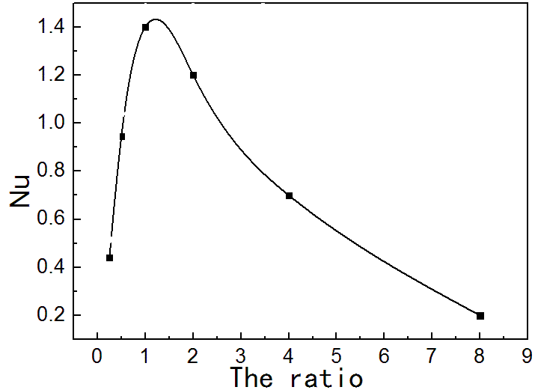

**Fig. 6** Average Nusselt number for varying ratio

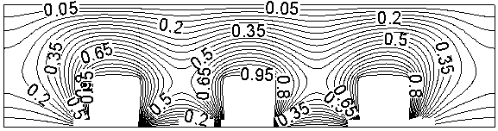

(a) Temperature field

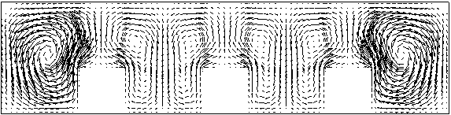

(b) Velocity vector field

**Fig. 4** Three heat sources

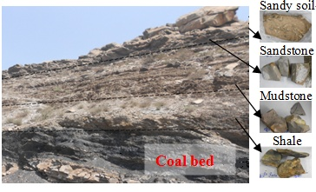

**Fig. 5** Stratum of the sampling site at coal fire area



**Fig. 6** Effect of surper heat on the ratio of the columnar, equiaxed and mixture

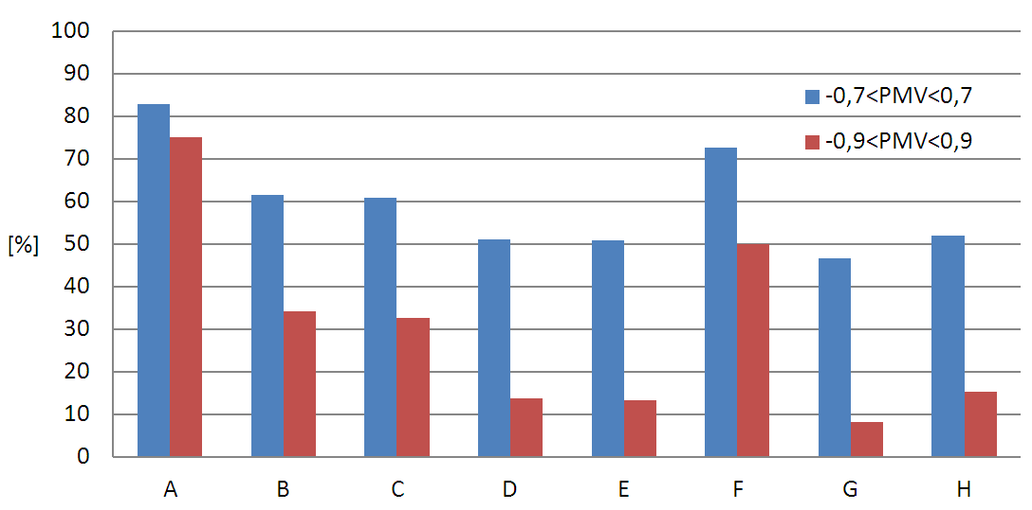

**Fig. 7** Percentage of hours during which the building is occupied and the PMV is out of the specified range (method A)

**7. Conclusions**

It is mandatory to have conclusions in your paper. This section should include the main conclusions of the research and a comprehensible explanation of their significance and relevance. Please do not make another abstract.

# acknowledgment

Acknowledgement section is not numbered and presented after the conclusion. Use the singular heading even if you have many acknowledgments. Avoid expressions such as “One of us (S.B.A.) would like to thank ...” Instead, write “F. A. Author thanks ...”.

**References**

In order to give our readers a sense of continuity, we encourage you to identify IJARI articles of similar research in your papers. Please do a literature check of the papers published in IJARI in recent years (up to 2016) at <http://www.IJARI.org/Journals/H%26TECH/ARCHIVE>.

Literature included in your references list must all be mentioned in the text. Please number all the pieces of literature in the order of their appearance in the text and mark them with Arabic numerals in square brackets, such as [1], [2], [3]… Please do not make these numerals superscript either in the text or in the references list.

Before submitting your paper, don’t forget to search DOI (Digital Object Identifier) for each piece of literature at [http://www.crossref.org/guestquery/#](http://www.crossref.org/guestquery/) and attach the result at the end of that piece, although not all published academic works have a DOI. (What is DOI? Please go to <http://www.doi.org/>.) Please pay attention to the following DOI example in red and strictly follow it:

[1] Caltagirone, J. P., “Thermoconvective instabilities in a horizontal porous layer,” *J. Fluid Mech.*, . 72,(2), 1975,.269-287 DOI: 10.1017/S0022112075003345.

Before making your references list, please read carefully and strictly imitate the following basic formats and corresponding examples for different types of literature

Basic format for books:

1. J. K. Author, “Title of chapter in the book,” in *Title of His Published Book, x*th ed. City of Publisher, Country: Abbrev. of Publisher, year, ch. *x*, sec. *x*, pp. *xxx–xxx.*

*Examples:*

1. A. Bejan, “Technology evolution, from the constructal law,” in *Advances in Heat Transfer*, vol. 45, E. M. Sparrow, Y. I. Cho, J. P. Abraham and J. M. Gorman, eds.; Burlington, USA: Academic Press, 2013, pp. 183-207. DOI: 10.1063/1.4886855.
2. W.-K. Chen, *Linear Networks and Systems.* Belmont, CA: Wadsworth, 1993, pp. 123–135.

Basic format for periodicals:

1. J. K. Author, “Name of paper,” *Abbrev. Title of Periodical*, vol. *x,* no. *x,* pp*. xxx-xxx,* Abbrev. Month, year.

*Examples:*

1. Yazid Y. SEBBAR, “Experimental study of convective heat flow through a large opening in a partitionned enclosure,” *Int J Heat & Tech*, 33(4), 2015, .211–216, DOI: 10.18280/ijht.330428.
2. A. Bejan, “Constructal self-organization of research: empire building versus the individual investigator,” *Int J Design & Nature Ecodyn*, 3,(3), 2008, 177-189,. DOI: 10.2495/DNE-V3-N3-177-189.
3. E. H. Miller, “A note on reflector arrays,” *IEEE Trans. Antennas Propagat*., to be published.

Basic format for reports:

1. J. K. Author, “Title of report,” Abbrev. Name of Co., City of Co., Abbrev. State, Rep. *xxx*, year.

*Examples:*

1. E. E. Reber, R. L. Michell, and C. J. Carter, “Oxygen absorption in the earth’s atmosphere,” Aerospace Corp., Los Angeles, CA, Tech. Rep. TR-0200 (4230-46)-3, Nov. 1988.
2. J. H. Davis and J. R. Cogdell, “Calibration program for the 16-foot antenna,” Elect. Eng. Res. Lab., Univ. Texas, Austin, Tech. Memo. NGL-006-69-3, Nov. 15, 1987.

Basic format for handbooks:

1. *Name of Manual/Handbook*, x ed., Abbrev. Name of Co., City of Co., Abbrev. State, year, pp. xxx-xxx.

Examples:

1. *Transmission Systems for Communications*, 3rd ed., Western Electric Co., Winston-Salem, NC, 1985, pp. 44–60.
2. *Motorola Semiconductor Data Manual*, Motorola Semiconductor Products Inc., Phoenix, AZ, 1989.

Basic format for books (when available online):

1. Author. (year, month day). *Title.* (edition) [Type of medium]. *volume (issue).* Available: site/path/file

*Example:*

1. J. Jones. (1991, May 10). *Networks.* (2nd ed.) [Online]. Available: [http://www.atm.com](http://www.atm.com/)

Basic format for journals (when available online):

1. Author. (year, month). Title. *Journal.* [Type of medium]. *volume (issue),* pages. Available: site/path/file

*Example:*

1. G. Casano and S. Piva. (2015, Dec.). Parametric analysis of a pcm energy storage system. *Int J Heat & Tech*.[Online]. *33(4),* pp. 61-68. Available: <http://www.iieta.org/sites/default/files/Journals/HTECH/33.4_08.pdf>

Basic format for papers presented at conferences (when available online):

1. Author. (year, month). Title. Presented at Conference title. [Type of Medium]. Available: site/path/file

*Example:*

1. PROCESS Corp., MA. Intranets: Internet technologies deployed behind the firewall for corporate productivity. Presented at INET96 Annual Meeting. [Online]. Available: <http://home.process.com/Intranets/wp2.htp>

Basic format for reports and handbooks (when available online):

1. Author. (year, month). Title. Company. City, State or Country. [Type of Medium]. Available: site/path/file

*Example:*

1. S. L. Talleen. (1996, Apr.). The Intranet Architecture: Managing information in the new paradigm. Amdahl Corp., CA. [Online]. Available:<http://www.amdahl.com/doc/products/bsg/intra/infra/html>

Basic format for computer programs and electronic documents (when available online): ISO recommends that capitalization follow the accepted practice for the language or script in which the information is given.

*Example:*

1. A. Harriman. (1993, June). Compendium of genealogical software. *Humanist.* [Online]. Available e-mail: [HUMANIST@NYVM.ORG](mailto:HUMANIST@NYVM.ORG) Message: get GENEALOGY REPORT

Basic format for patents (when available online):

1. Name of the invention, by inventor’s name. (year, month day). *Patent Number* [Type of medium]. Available: *site/path/file*

*Example:*

1. *Musical toothbrush with adjustable neck and mirror, by L.M.R. Brooks*. (1992, May 19). *Patent D 326 189*

[Online]. Available: NEXIS Library: LEXPAT File: DESIGN

Basic format for conference proceedings (published):

1. J. K. Author, “Title of paper,” in *Abbreviated Name of Conf.*, City of Conf., Abbrev. State (if given), year, pp. *xxxxxx.*

*Example:*

1. D. B. Payne and J. R. Stern, “Wavelength-switched pas- sively coupled single-mode optical network,” in *Proc. IOOC-ECOC,* 1985, pp. 585–590.

*Example for papers presented at conferences (unpublished):*

1. D. Ebehard and E. Voges, “Digital single sideband detection for inter-ferometric sensors,” presented at the 2nd Int. Conf. Optical Fiber Sensors, Stuttgart, Germany, Jan. 2-5, 1984.

Basic format for patents:

1. J. K. Author, “Title of patent,” U.S. Patent *x xxx xxx*, Abbrev. Month, day, year.

*Example:*

1. G. Brandli and M. Dick, “Alternating current fed power supply,” U.S. Patent 4 084 217, Nov. 4, 1978.

Basic formatfor theses (M.S.) and dissertations (Ph.D.):

1. J. K. Author, “Title of thesis,” M.S. thesis, Abbrev. Dept., Abbrev. Univ., City of Univ., Abbrev. State, year.
2. J. K. Author, “Title of dissertation,” Ph.D. dissertation, Abbrev. Dept., Abbrev. Univ., City of Univ., Abbrev. State, year.

*Examples:*

1. J. O. Williams, “Narrow-band analyzer,” Ph.D. dissertation, Dept. Elect. Eng., Harvard Univ., Cambridge, MA, 1993.
2. N. Kawasaki, “Parametric study of thermal and chemical nonequilibrium nozzle flow,” M.S. thesis, Dept. Electron. Eng., Osaka Univ., Osaka, Japan, 1993.

Basic format for the most common types of unpublished references:

1. J. K. Author, private communication, Abbrev. Month, year.
2. J. K. Author, “Title of paper,” unpublished.
3. J. K. Author, “Title of paper,” to be published.

*Examples:*

1. A. Harrison, private communication, May 1995.
2. B. Smith, “An approach to graphs of linear forms,” unpublished.
3. A. Brahms, “Representation error for real numbers in binary computer arithmetic,” IEEE Computer Group Repository, Paper R-67-85.

Basic format for standards:

1. *Title of Standard*, Standard number, date.

*Examples:*

1. IEEE Criteria for Class IE Electric Systems, IEEE Standard 308, 1969.
2. Letter Symbols for Quantities, ANSI Standard Y10.5-1968.

**Nomenclature**

Each paper must have a separate nomenclature section that lists in detail and unambiguously all the symbols used in the text and their definitions. Do not use the same symbol for two or more different meanings or definitions; similarly, do not use more than one symbol for one variable/parameter. Each dimensional symbol must have SI units mentioned at the end. All dimensionless groups and coefficients must be indicated as dimensionless after their definitions. All Latin symbols (dimensional and dimensionless) should be listed in an alphabetic order. All Greek symbols follow the Latin symbols. Subscripts and superscripts follow Greek symbols, and should be identified by a minor heading. Symbols that cannot be typed should be entered in black ink. Symbols should be italicized throughout the text.

Please make a nomenclature originally in a table and then hide all the borders so that the symbol column and the meaning column can be aligned from the top down. Here is a template for nomenclature:

**Nomenclature**

|  |  |
| --- | --- |
| B | dimensionless heat source length |
| CP | specific heat, J. kg-1. K-1 |
| g  k | gravitational acceleration, m.s-2  thermal conductivity, W.m-1. K-1 |
| Nu | local Nusselt number along the heat source |
| **Greek symbols** |  |
| α | thermal diffusivity, m2. s-1 |
| β | thermal expansion coefficient, K-1 |
| φ | solid volume fraction |
| Ɵ | dimensionless temperature |
| µ | dynamic viscosity, kg. m-1.s-1 |
| **Subscripts** |  |
| p | nanoparticle |
| f | fluid (pure water) |
| nf | nanofluid |

**Other Tips**

1. Footnotes. Try to integrate the footnote information into the text.
2. Appendix. If there is an Appendix section in your paper, please place the section after Nomenclature and follow the format of the text body.
3. Permissions. You are responsible for making sure that you have the right to publish everything in your paper. If you use material from a copyrighted source, you may need to get permission from the copyright holder. You need to seek permission to use a figure or table if it has not been changed in any substantive way from the original or if it does not plot or compile data readily available to anyone. You need to seek permission to quote material if you use it in a way competitive with the original material, that is, if your use of the material will harm the rights of the original publisher and/or author. This criterion holds true regardless of the length of the quote. If the quoted material will not be used competitively, you need only to cite the original source. Please consult your own legal adviser if you have any questions about what may need permission.